Task-01: Secure User Authentication
Implement a user authentication system with secure login and registration functionality. Users should be able to sign up for an account, log in securely, and access protected routes only after successful authentication.
Optional: Use standard mechanisms to handle password hashing, session management, and user role-based access control.

🔹 Step 1: Create Project Folder
- Create a folder named:secure-auth
- Open this folder in VS Code
- Open Terminal inside the folder

🔹 Step 2: Initialize Node Project
Run this command:
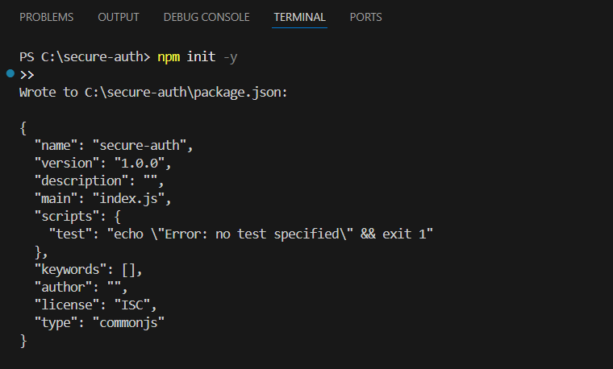

🔹 Step 3: Install Required Packages
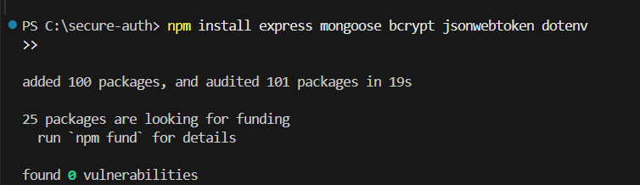

🔹 Step 4: Create Folder Structure
Inside secure-auth, create:
secure-auth
│
├── models
│ └── User.js
│
├── routes
│ └── authRoutes.js
│
├── middleware
│ └── authMiddleware.js
│
├── .env
└── server.js

🔹 Step 5: Setup MongoDB Connection (server.js)
const express = require("express");
const mongoose = require("mongoose");
require("dotenv").config();

const app = express();
app.use(express.json());

mongoose.connect(process.env.MONGO_URI)
.then(() => console.log("MongoDB Connected"))
.catch(err => console.log(err));

app.use("/api/auth", require("./routes/authRoutes"));

app.listen(3000, () => {
console.log("Server running on port 3000");
});

🔹 Step 6: Create User Model (models/User.js)
const mongoose = require("mongoose");
const userSchema = new mongoose.Schema({
username: String,
email: String,
password: String
});
module.exports = mongoose.model("User", userSchema);

🔹 Step 7: Registration API (routes/authRoutes.js)
const express = require("express");
const bcrypt = require("bcrypt");
const User = require("../models/User");
const router = express.Router();

router.post("/register", async (req, res) => {
const hashedPassword = await bcrypt.hash(req.body.password, 10);

const user = new User({
username: req.body.username,
email: req.body.email,
password: hashedPassword
});

await user.save();
res.json({ message: "User registered successfully" });
});

module.exports = router;

🔹 Step 8: Login API with JWT
Add this inside authRoutes.js:
const jwt = require("jsonwebtoken");

router.post("/login", async (req, res) => {
const user = await User.findOne({ email: req.body.email });

if (!user) return res.status(400).json({ message: "User not found" });

const isMatch = await bcrypt.compare(req.body.password, user.password);
if (!isMatch) return res.status(400).json({ message: "Invalid password" });

const token = jwt.sign({ id: user._id }, process.env.JWT_SECRET);
res.json({ token });
});

🔹 Step 9: Create Auth Middleware (middleware/authMiddleware.js)
const jwt = require("jsonwebtoken");

module.exports = function (req, res, next) {
const token = req.header("Authorization");

if (!token) return res.status(401).json({ message: "Access denied" });

try {
jwt.verify(token, process.env.JWT_SECRET);
next();
} catch {
res.status(400).json({ message: "Invalid token" });
}
};

🔹 Step 10: Create Protected Route
Add in server.js:
const auth = require("./middleware/authMiddleware");

app.get("/protected", auth, (req, res) => {
res.send("Access Granted");
});

🔹 Step 11: Create .env File
MONGO_URI=mongodb://127.0.0.1:27017/secure-auth
JWT_SECRET=mysecretkey

🔹 Step 12: Run the Project
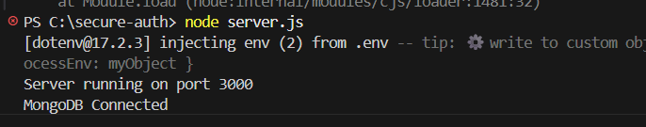

🔹 Step 13: Test Using Postman

✅ Register:
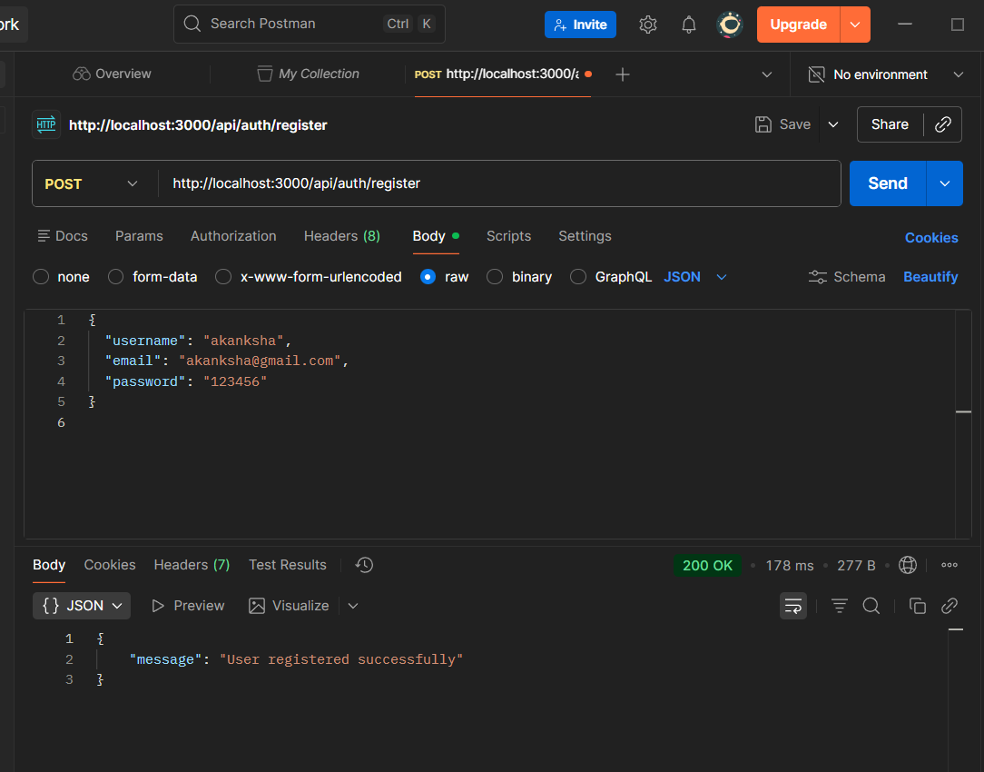

✅ Login:
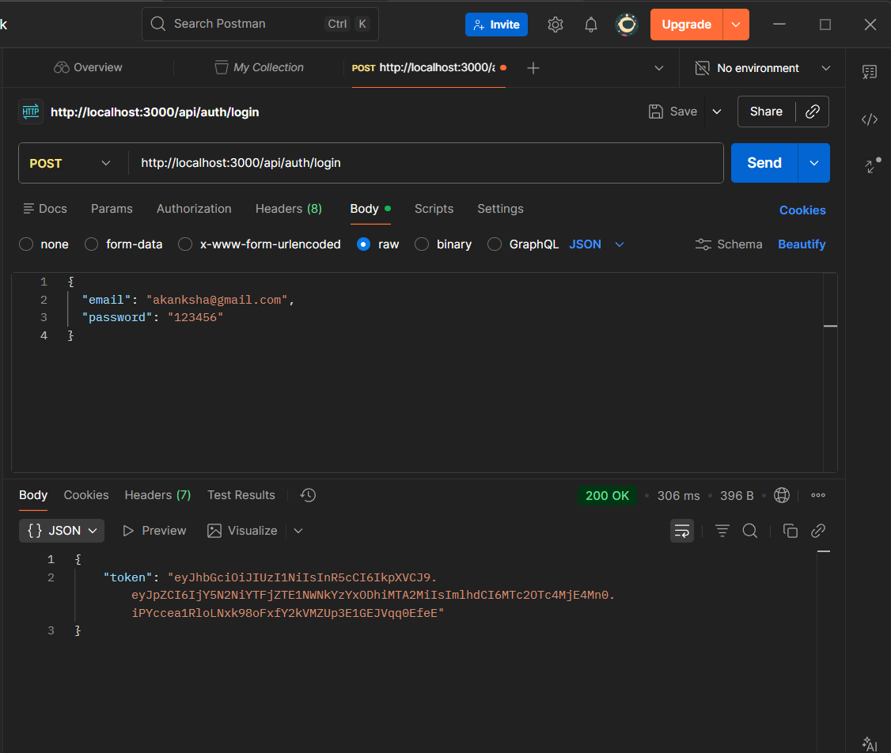
✅ Protected Route:
1. If token is invalid:

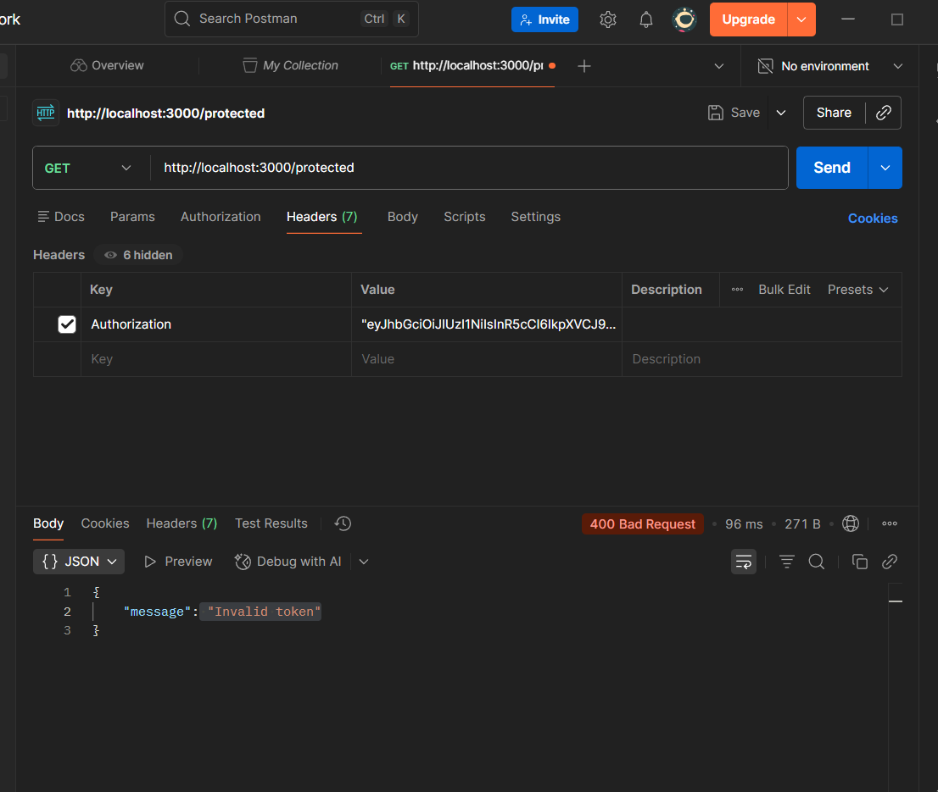
2. If token is Valid
